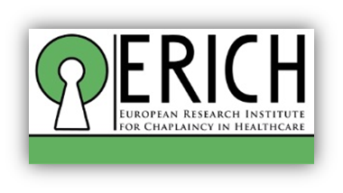
A call for colleagues in the USA to collaborate in Patient Reported Outcome Research (PROM)

Who is asking?
The European Research Institute for Chaplains in Healthcare (ERICH) was formed just over a year ago and is hosted by Professor Anne Vandenhoeck at the University of Leuven in Belgium. Supported by a philanthropic grant, it is a ‘research institute initiated by chaplains, for chaplains to enhance spiritual care practice’. It has an international board, with George Fitchett and Christina Puchalski giving it a strong US presence. Since inception in June 2017 ERICH has focused on developing patient reported outcome measure (PROM) research for spiritual care across Europe.
What is PROM research for spiritual care?
The research is designed to answer the fundamental question: ‘What difference do chaplains make?’. This question is answered by patients. To create generalizable findings, all participating studies use the Scottish Patient Reported Outcome Measure (PROM). This short questionnaire was created and validated in Scotland by Rev Iain Telfer and Professor Snowden (lead researcher in ERICH), hence the ‘Scottish PROM’. The Scottish PROM contains a set of five questions that cannot be changed, or results of one study could not be compared with another. However, there is scope for different projects to add cultural or clinically specific questions.
To date, chaplains in Belgium, Czech Republic, Estonia, The Netherlands, UK, Ireland and Germany have engaged with ERICH to explore collaboration in PROMs research in a variety of healthcare contexts: acute, palliative, older peoples’, mental health and rehabilitative care in institutional, community and residential care home settings. This is a tremendous start to our three-year programme of PROMs research and we would now like to invite colleagues from USA to express interest too. We would be delighted to hear from you.
Want to know more?
If you are interested to know more about the PROMS for spiritual care, please contact Professor Anne Vandenhoeck, director of ERICH at anna.vandenhoeck@kuleuven.be or Professor Austyn Snowden at a.snowden@napier.ac.uk
You will be invited for an informative online presentation about the PROMS for spiritual care which will also explore options to do research in the US. Professor Vandenhoeck and Professor Snowden are both members of the Joint Research Council of the Association for Professional Chaplains. Further information about them and the research is at the following website: http://www.chaplaincyresearch.eu

