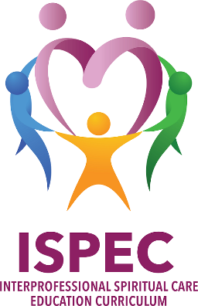
Join us Tuesday, 9-11am, January 10, 2019 to hear local chaplains and partnering clinicians share their experience with interdisciplinary health care team training! Sponsored by the MN chapter of the Association of Professional Chaplains (APC) and hosted by St. Catherine University in St. Paul, the panel will share what they learned during the Interprofessional Spiritual Care Education Curriculum in Washington D.C. at the George Washington University Institute for Spirituality and Health this past summer. Local panel members will include ISPEC faculty member Chaplain Paul Galchutt (also a Transforming Chaplaincy Fellow), Our Lady of Peace Hospice team Chaplain Amy Cotter and Deb Lane, RN CHPN, and Hennepin Healthcare team Dr. Eileen O’Shaughnessy and Chaplain Manager David Hottinger.
Come learn about this groundbreaking curriculum and how you and your health care setting can get involved!
All chaplains, chaplain students, faculty or educators are welcome. No fee.
Event will be in the Recital Hall. On the attached map, it is building # 6. Parking available just to east of the building.
To learn more about ISPEC click on this link: https://smhs.gwu.edu/gwish/interprofessional-spiritual-care-education-curriculum-ispec
Created by Co-Directors: Christina Puchalski, MD, FACP, FAAHPM & Betty Ferrell, RN, PhD, FAAN, FPCN
Christina Puchalski, MD, director of the George Washington University (GW) Institute for Spirituality and Health, professor of medicine at the GW School of Medicine and Health Sciences, and medical director of professional health hospice of Washington, DC, was named one of the 30 most influential leaders in hospice and palliative medicine. She and Betty Ferrell are the authors of the groundbreaking book, Making Health Care Whole: Integrating Spirituality into Patient Care. For more information, visit www.gwish.org .

